CREATE JAVA APPLICATION

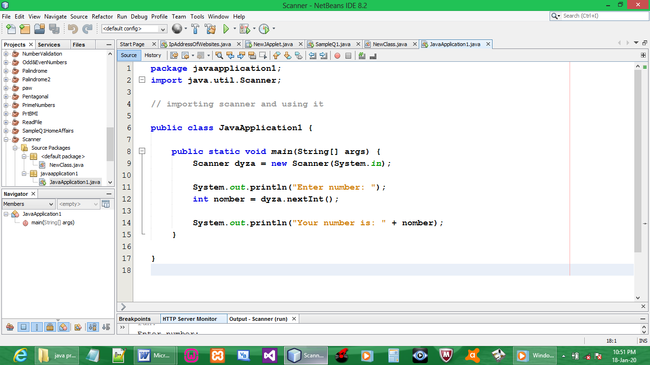

CODE:

package javaapplication1;
import java.util.Scanner;

// importing scanner and using it

public class JavaApplication1 {

public static void main(String[] args) {
Scanner dyza = new Scanner(System.in);

System.out.println("Enter number: ");
int nomber = dyza.nextInt();

System.out.println("Your number is: " + nomber);
}

}

OUTPUT:

